|  |
| --- |
| Architectural Proposal Template |

|  |
| --- |
| **Prepared by:**  [Sender.FirstName] [Sender.LastName]  [Sender.Company] |

|  |
| --- |
| **Prepared for:**  [Client.FirstName] [Client.LastName]​ [Client.Company] |

|  |
| --- |
|  |

|  |  |
| --- | --- |
| Re: Enclosed proposal | Please find enclosed our detailed proposal for your kind consideration.  We know that realizing creative projects requires a unique combination of drive, ambition, skill and technical know-how so at **[Sender.Company]** we only hire the best to ensure we provide a turnkey solution for our clients that is both realistic and extraordinary!  **[Sender.Company]** prides itself on turning in projects on-time and within budget so if you would like to contact some of our hundreds of satisfied clients then please let me know. We have full confidence that whoever you speak to you will hear nothing but ringing endorsements. You can also check out our portfolio of recent work online at **[Sender.Website]**.  We care about each and every client and will work our hardest to design a safe and exciting home for you and your family. We also follow best practices in the areas of ergonomic home planning and environmentally-friendly design to make your home efficient and save you money on the cost of utilities.  ​  Please let us know if you have any questions, suggestions or changes (however small) to the proposal; we really want to hear from you!  Finally, we realize that you are very busy and wanted to thank you in advance for your time spent reviewing our proposal. We hope that you will give us this opportunity to deliver you an on-time and on-budget dream-home. |

## Yours Truly,

## [Sender.FirstName] [Sender.LastName]

### Executive summary

|  |  |
| --- | --- |
| The executive summary should comprise 100-500 words explaining a top-down view of the salient points of this proposal. It should include sufficient detail to outline the project and engage the reader’s interest so they will continue through the architectural proposal. It should provide a precis of the the later information, and specifically it should present an overview of the detailed proposal, some details about the firm and the staff member/s who will be working on the project as well as a summary of the the sketches and plans. You can use pictures here to fill out the page but you should not waffle, the place for sales patter is in the cover letter above. Many architectural proposals use this opportunity to present high resolution images of previous successful projects. |  |

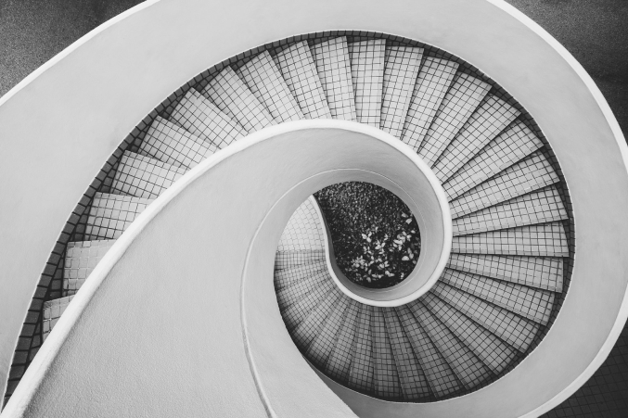

|  |  |
| --- | --- |
| Detailed proposal | The Brief |

|  |  |
| --- | --- |
| Our approach | We believe that each client is unique and so we take a unique approach to each brief. In this case we have noted and analyzed your requirements as well as undertaking a thorough review of the site including a feasibility analysis and a detailed costing and modeling of the whole project. Drawing on our long experience in this area we have tailored a solution to your exact specifications by fusing form and function to create the ideal space for you. In practical terms we have also identified and outlined key strategic milestones in the life of the project to ensure a smooth completion as well as accountability throughout all stages of the build and compliance with all local and national laws and regulations. |

|  |  |
| --- | --- |
| The proposal | Outline the brief here, do not mention timescales or fees, as they are covered later. Make reference to any drawings or plans which are relevant to the points you are making in this proposal. |

## Project milestones

|  |  |
| --- | --- |
| Milestone 1 Approval of sketches and concept drawings. Milestone 2 Preparing of plans. Milestone 3 Preparation of planning permission application. Milestone 4 Receive planning permission.. Milestone 5 Breaking earth (lot 555100). Milestone 6 Completion of foundations and basement. | Milestone 7 1st floor complete. Milestone 8 Roofing Milestone 9 Plumbing and electrics. Milestone 10 Interior modeling. Milestone 11 Interior finishing. Milestone 12 Landscaping |
| For each milestone try to provide a short description. Obviously the milestones will depend on the project but would normally include key events in the project’s life especially those depending on outside agencies (such as planning authorities or builders’ merchants) as well as key stages in the project’s completion (such as the laying of foundations etc.). | You should include dates here (if possible) and if you wish you can include the percentage completion through the whole project near each milestone. When choosing milestones you should bear in mind both the payment of fees (yours and contractors) and the ordering and delivery of materials. |

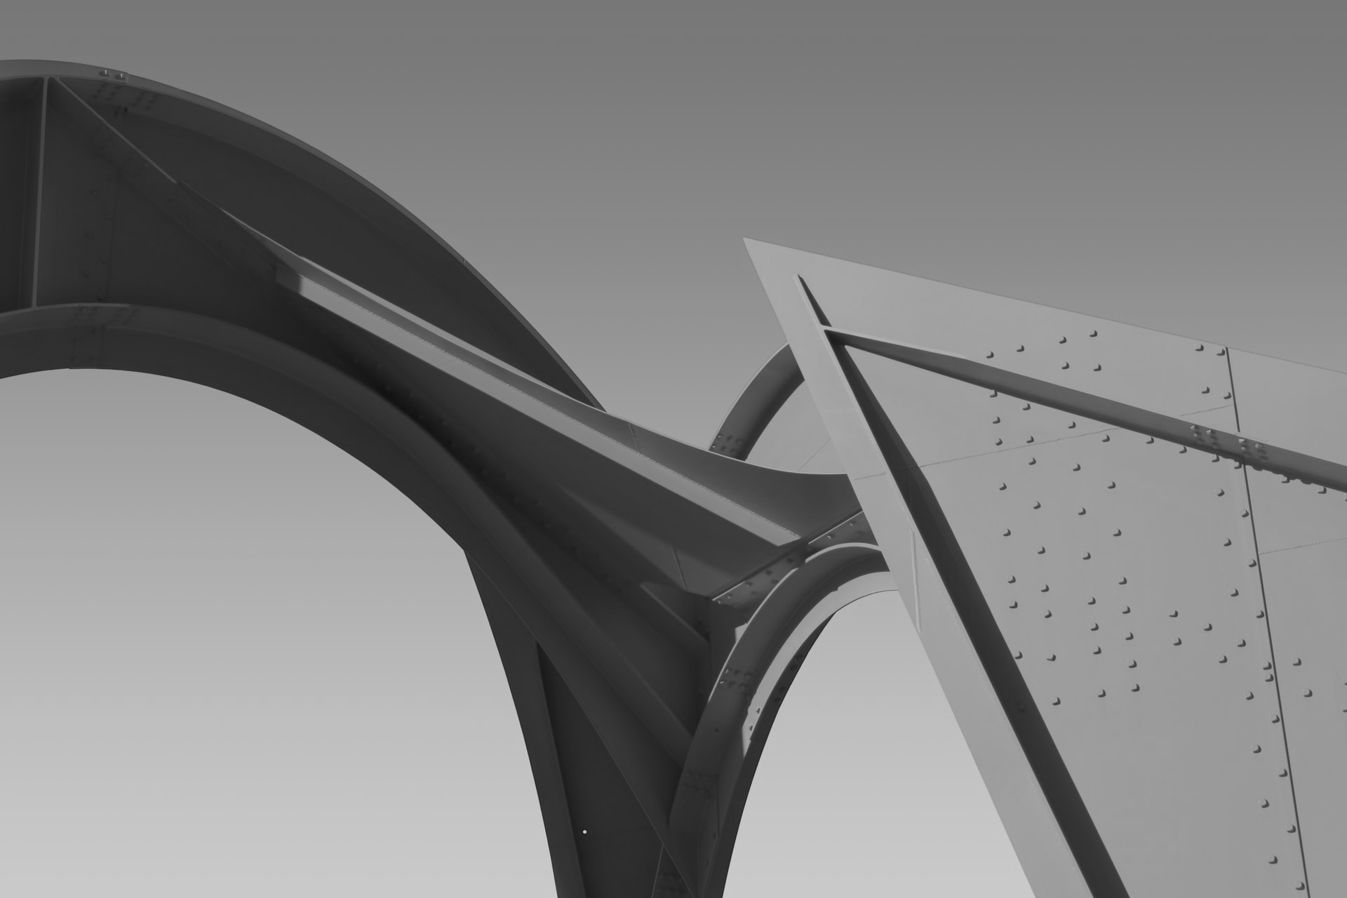

### Firm’s profile

**[Sender.Company]** is a leading firm in **GEOGRAPHIC AREA** specializing in customer-oriented design and project-management to make your dream home and garden a reality. **[Sender.Company]** has unique expertise in the areas of both new builds and home renovations and has been operating since year. **[Sender.Company]**has assisted hundreds of clients across multiple industries including private clients, local government and schools as well as major state and national businesses. Our previous clients include **PREVIOUS CLIENTS**.

### Key staff

Include the bios of some key figures from the firm, especially the owner and the person in charge of this project. Include photographs as well since people like to have a face to put to a name on the phone or by email. If you have a standard bio (perhaps from the website) you can use this, otherwise you can create one around 50-150 words detailing their experience, the date of their qualifications and any other similar projects which the architect has worked on.

### Pricing

Our fee for seeing the project through from start to completion will be **FEE**. In addition to this you should also budget approximately **BUDGET** for additional materials and outsourcing of labour.

## Payment terms

We propose the following payment terms:

|  |  |  |  |  |  |  |  |  |  |  |  |  |
| --- | --- | --- | --- | --- | --- | --- | --- | --- | --- | --- | --- | --- |
| **10** | % (10%) | | | | | | Paid on acceptance of this architectural proposal and signing of our terms and conditions. | | | | | |
| **20** | | | % (30%) | | | | | Paid at Milestone 1, completion of drawing and sketches. | | | | |
| **30** | | % (60%) | | | | | | | | Paid at Milestone 4, planning permission being granted. | | |
| **10** | | | | % (70%) | | | | | Paid at Milestone 6, basement level completion. | | | |
| **20** | | | | | % (90%) | | | | | | Paid at Milestone 8, roofing complete. | |
| **10** | | | | | | % (100%) | | | | | | Paid on completion of project. |

## Contact us

You can get in touch with us in any of the below ways:

|  |  |  |
| --- | --- | --- |
| By PhoneBy EmailBy FaxOn Our WebsiteBy Post | [Salesman.Phone] (Cellphone of **SALESMAN**)  [Sender.Phone] (Main Reception)  [Sender.Email]​  [Sender.Phone]​  [Sender.Website]  [Sender.StreetAddress] [Sender.City] [Sender.State] [Sender.PostalCode]​ | |
| If you would like to proceed with our proposal then you can sign the Terms and Conditions page (below) and return it to us by fax, email or post.  In any case please feel free to call us to discuss the quote, request more information or for any other reason. We look forward to hearing from you soon! | |  |

## Terms and сonditions

The following terms and conditions shall form the basis of a contract between the [Client.Company] (“Client”) and [Sender.Company]​ (“Firm”) in the event that the client decides to proceed and accepts this proposal:

1. The Firm agrees to provide the services outlined in this proposal for the fee outlined above.

2. The Client undertakes to pay the fee set out above in accordance with the agreed payment milestones.

3. The Firm undertakes to consult with the Client in order to facilitate the completion of the agreed milestones above as well as the completion of the project as a whole.

4. The Client undertakes to provide the Firm with clear instructions and guidance when required.

5. The Firm will ensure compliance with all relevant laws and regulations.

6. The Firm shall undertake all of its work with professionalism and due care.

7. The Firm may outsource work or manage contractors.

8. The Client undertakes not to withhold payment for any reason.

9. Any subsequent agreement, whether written or oral, between the Firm and the Client shall override the terms of this architectural proposal.

10. The Firm is not responsible for delays due to outside agencies such as planning or government

authorities, builders’ merchants, shipping and transit companies and third-party contractors.

11. The Firm is not responsible for delays due to unforeseen eventualities or acts of God such as poor weather, flooding, natural disaster etc.

12. The Firm is not responsible for increases in costs caused by a future rise in the costs of materials (including outside contractors) or by a later lack of availability of those materials used as a basis for calculated costing in our proposal.

13. The Client undertakes to insure and keep insured the site against injury to third-parties and contractors.

14. Although every care has been taken in the preparation of this proposal it is not possible to predict with complete certainty the cost and timescale of any architectural project and the Client should allow at least a 10% margin on costs and timescales.

**Signed as accepted,**

[Client.FirstName] [Client.LastName]​[Client.Company]

