Construction Equipment
Lease Proposal

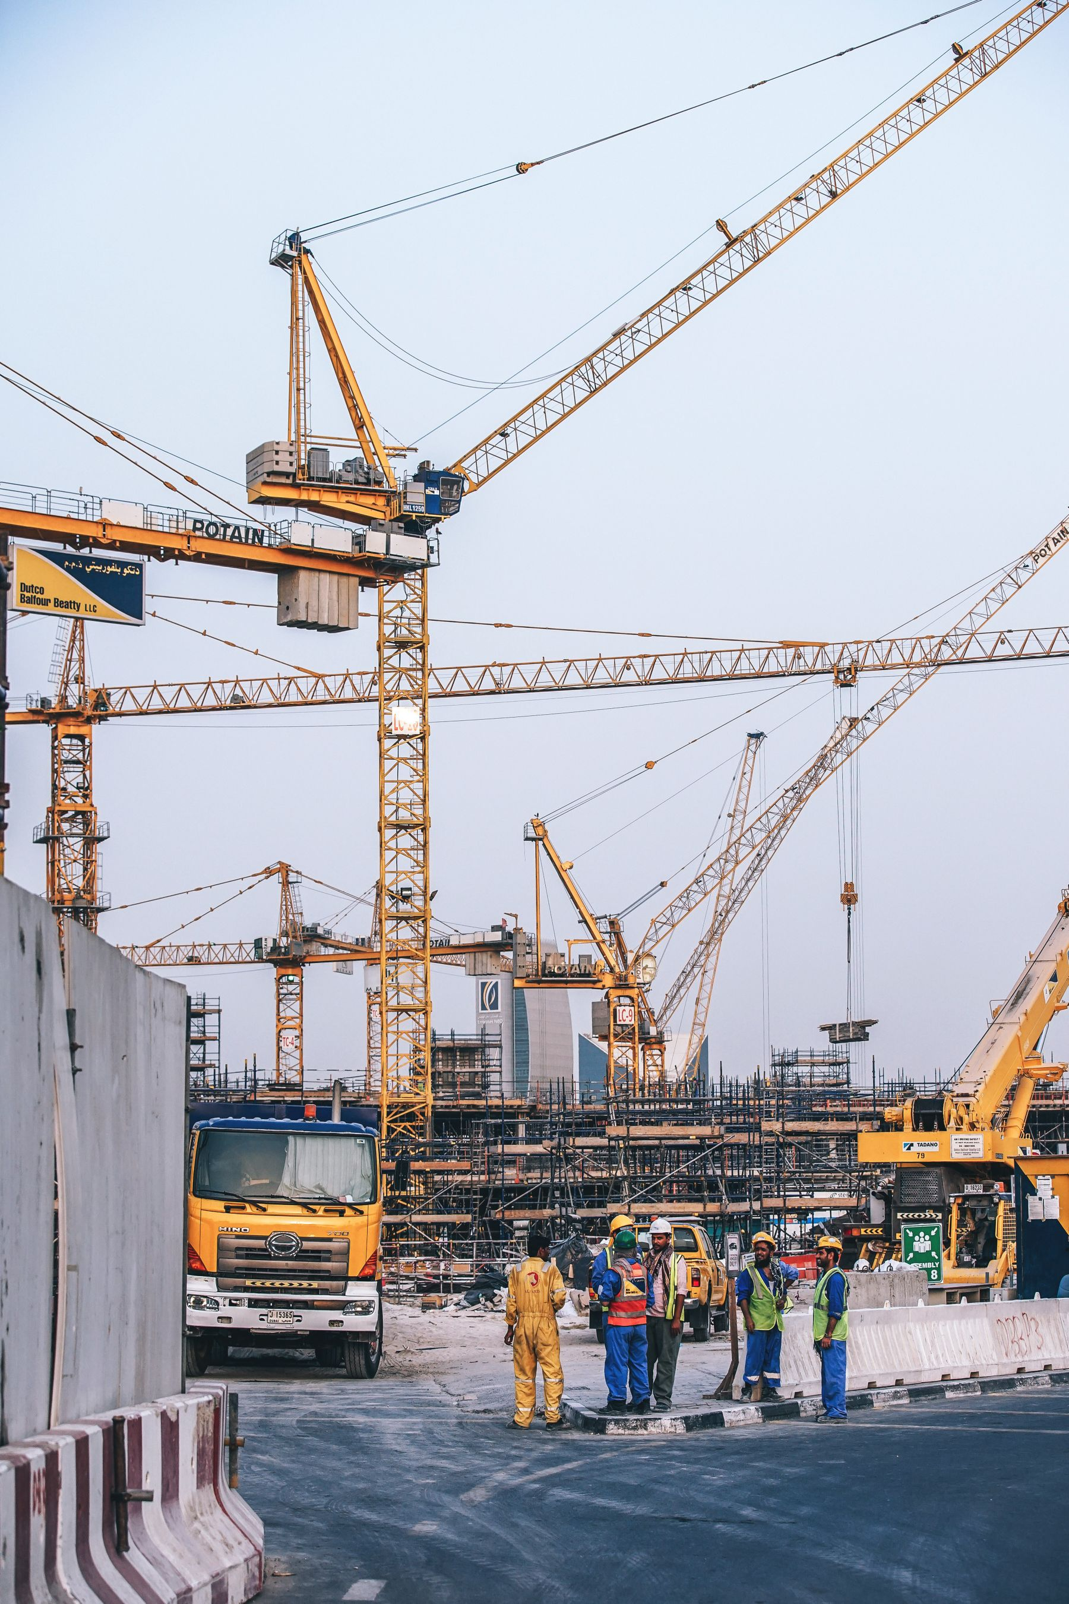

Prepared for [Client.Company]
By [Sender.Company]

Cover Letter

Dear [Client.FirstName] [Client.LastName],

At [Sender.Company], Construction Equipment Leasing is ALL WE DO! Lease your Construction Equipment with confidence , we will provide what you need, when you need it, all the time. Our 24/7 hotline provides you with wide ranging solutions for all Construction Equipment situations you might encounter.

We backed up our commitment with a 4 point guarantee! They are:
Client Satisfaction
Dependable Delivery
On Site Service
Customer Service Hotline

Leave all your equipment worries with us. Use your capital where it matters, not on equipment.

Sincerely,

[Sender.FirstName] [Sender.LastName]
[Sender.Company] ​

Executive Summary

The Problem

Construction Companies and Owners know how capital intensive and prohibitive the industry is. The rising cost for materials, equipment, labor and the diminishing availability of construction projects has shrunken the profitability of the business. Construction companies need to be innovative and creative in using their assets and capital to survive the competition.

Our Solution

Why lease your construction equipments from us?

Simple – we‘ll help you maximize your Cash Flow, increase your profits, minimize balance sheet liabilities while decreasing your taxable income! Plus you’ll get to use the best equipment available needed for every construction job you have, backed up by our 24/7 service guarantee.

For an agreed upon rate of payment, our company will provide the equipment you’ll need for your construction projects. Spend money on equipment only when you use it! No more spending much needed company funds or tying up valuable lines of credit to purchase capital construction equipments. You can use this freed up cash and credit lines for operation funds, company expansion, maximizing flexibility, strategic positioning, or retire long term obligations.

Because an equipment lease payment is an expense account, the liabilities entry for your balance sheet will not suffer, making investors and shareholders alike happy. More importantly, operational expenses, such as equipment lease expense, are tax deductible. This means more income for you and your company!

We offer flexible terms for your equipment leasing needs. We have Monthly, Weekly, even Daily Rates that are configurable to suit all your project requirements. We can even assist in designing the payment structure to reconcile with your budget and cash flow. We also have flexible renewal options available. Just ask our helpful staff for all available options and solutions.

Leasing your construction equipment from us is the innovative and cost effective business solution. Give us a call or visit our website for a quote on your equipment leasing requirements. Better yet, visit our office to view our top of the line construction equipments.

Company Profile

Company Name | [Sender.Company]
Head Office Address
Email Address
Website
Telephone Number
Full Time Employees | /Number of full time employees/
Part Time Employees | /Number of part time employees/
Gross Sales Last Year | /Gross sales last year/

Past and Present Clients | 

Awards & Recognitions Earned

Type your text here...

License & Permits

Equipment for Lease

Type your text here...

Detailed Estimation

Name | Price | QTY | Subtotal
 | $0.00 | 1 | $0.00
$0.00

Subtotal | $0.00
Discount | $0.00
Tax | $0.00
Total | $0.00

Construction Equipment Lease Agreement

THIS CONSTRUCTION EQUIPMENT LEASE AGREEMENT is entered into on May 12 by and between: [Client.Company] hereinafter referred to as the “LESSEE” and [Sender.Company] hereinafter referred to as the “LESSOR”

WHEREAS the LESSEE is desirous of leasing Construction Equipment.
WHEREAS the LESSOR is a duly and registered and licensed Construction Equipment Leasing Company.

WHEREAS the LESSOR agree to lease the stated Construction Equipment/s described and identified below under the heading Details of Equipment for use at such location, for such Guaranteed Rental Period and at such rental rates as herein to the LESSEE.

NOW THEREFORE both parties bind themselves and agree as follows:

1. Equipment

LESSOR hereby leases to LESSEE the following equipment:

EQUIPMENT
MODEL/MAKE/SN
LOCATION
RENTAL PERIOD
VALUE FOR INSURANCE

2. Rental Period

Begin Date:
End Date:

The Rental Period shall cover all time consumed in transporting the equipment including the date of legal delivery to a carrier for transit to the LESSEE and return of the equipment including the date of legal delivery by such carrier to LESSOR.

3. Calculation of Rental Charges

3.1 MONTHLY RENTAL RATES: are for a period of one month 4 weeks (28 days), computed from the date of commencement of the rental period up to but not including the same date in the next calendar month and shall apply when the number of hours the equipment is operated in any one month does not exceed 200 (two hundred) hours.

3.2 WEEKLY RENTAL RATES: are for a minimum period of one week (7 days), from the day of commencement of the rental period up to but not including the same day in the following week and shall apply when the number of hours the equipment is operated in any one week does not exceed 50 (fifty) hours.

3.3 DAILY RENTAL RATES: are for a consecutive period of 24 (twenty four) hours or less which the number of hours the equipment is operated shall not 10 (ten) hours.

3.4 OVERTIME CHARGES: where equipment is operated in excess of the above stated hourly maxima, such excess shall be charge at ([PERCENT OVERTIME CHARGES]%).

3.5 After the monthly or weekly rental period has expired, the rental payable for a fraction of any succeeding period shall be the proportionate part of the applicable rental rate according to the number of calendar days in such fraction.

3.6 Rental rates shall not be subject to any deduction for any non-working time during the rental period, nor because the LESSEE returns the equipment to LESSOR before the expiration of the Guaranteed Rental Period.

3.7 LESSOR and LESSEE for themselves, their successors, executors, administrators and assigns, hereby agree to the full performance of the covenants herein contained.

4. Payment

Rentals payable under this Agreement shall be monthly when the rental is at a monthly rate, otherwise weekly, and in either case same shall be payable PAID IN ADVANCE at LESSOR’s Business Address without the need for prior demand or invoice. Rent is payable before delivery of equipment to the LESSEE or his/its agent or carrier and on succeeding monthly or weekly dates thereafter running from the date of delivery.

5. Late/Overdue Charges

If any amount under this Agreement is more than 30 days late, LESSEE agrees to pay a late fee of $30.000. Overdue payments shall bear an interest of (30%) per annum.

6. Security Deposit/Bond

Prior to taking possession of the Equipment, LESSEE shall deposit with LESSOR, in trust, a Security Deposit/Bond in the amount of the value of the equipment as shown in the Details of Equipment as security for the performance by LESSEE of the terms under this Agreement and for any damages caused by LESSEE or LESSEE’s agents to the Equipment during the Lease Term.

LESSOR may use part or all of the Security Deposit to repair any damage to Equipment caused by LESSEE or LESSEE’s agents. However, LESSOR is not just limited to the security deposit amount and LESSEE remains liable for any balance. LESSEE shall not apply or deduct any portion of any Security Deposit from the last or any month's rent. LESSEE shall not use or apply any such Security Deposit at any time in lieu of payment of rent. If LESSEE breaches any terms or conditions of this Agreement, LESSEE shall forfeit any deposit, as permitted by law.

7. Delivery

LESSEE shall be responsible for all expenses and costs:

7.1 at the beginning of the Lease Term, of shipping the Equipment to Equipment Lease Agreement to LESSEE’s premises, and

7.2 at the end of the Lease Term, of shipping the Equipment back to LESSOR’s premises.

8. Default

8.1 If LESSEE fails to perform or fulfill any obligation under this Agreement, LESSEE shall be in default of this Agreement. Subject to any statute, ordinance or law to the contrary, LESSEE shall have seven (7) days from the date of notice of default by LESSOR to cure the default. In the event LESSEE does not cure a default, LESSOR may at LESSOR’S option:

8.1.1 cure such default and the cost of such action may be added to LESSEE’s financial obligations under this Agreement; or

8.1.2 Declare LESSEE in default of the Agreement.

8.2 If LESSEE shall become insolvent, cease to do business as a going concern or if a petition has been filed by or against LESSEE under the Bankruptcy Act or similar federal or state statute, LESSOR may immediately declare LESSEE in default of this Agreement WITHOUT NOTICE. In the event of default, LESSOR may, as permitted by law, re-take possession of the Equipment. LESSOR may, at its option, hold LESSEE liable for any difference between the RENT that would have been payable under this Agreement during the balance of the unexpired term and any rent paid by any successive LESSEE if the Equipment is re-let minus the cost and expenses of such re-letting. In the event LESSOR is unable to re-let the Equipment during any remaining term of this Agreement, after default by LESSEE, LESSOR may at its option hold LESSEE liable for the balance of the unpaid rent under this Agreement if this Agreement had continued in force.

9. Possession of Equipment

LESSEE shall be entitled to possession of the Equipment on the first day of the Lease Term. At the expiration of the Lease Term, LESSEE shall surrender the Equipment to LESSOR by delivering the Equipment to LESSOR or LESSOR’S agent in good condition and working order, ordinary wear and tear excepted, as it was at the commencement of the Agreement.

10. Use of Equipment

LESSEE shall only use the Equipment in a careful and proper manner and will comply with all laws, rules, ordinances, statutes and orders regarding the use, maintenance and storage of the Equipment.

11. Maintenance, Operation and Repairs

THE LESSEE DECLARES THAT HE OR ITS EMPLOYEES UNDERSTAND THE OPERATION OF THE EQUIPMENT. The LESEE shall not remove, alter, disfigure or cover up any numbering, lettering or insignia displayed upon the equipment, and shall ensure that the equipment is not subjected to careless or needlessly rough usage, and shall at the LESEE’s own expense, maintain and ultimately return to LESSOR the equipment and its appurtenances in good repair and operating condition. Without limiting the generality of the foregoing, the LESEE shall, at the LESEE’s own expense, during the term of this rental pay the cost of:

11.1 All fuel, oil and lubricants required to operate the equipment.

11.2 All repairs and replacement parts including labor charges, required to be made to the equipment in order to keep it in good repair and running order.

12. Damage to Equipment

The LESEE shall indemnify LESSOR against all loss and damage to the equipment hereby obtained, during the rental period, based on the value of such equipment stated in the Details of Equipment. LESSOR shall give notice to the LESSEE as soon as possible of any claim of LESSOR under this paragraph. In addition, the obligations of this Agreement shall continue in full force and effect through the Lease Term.

13. Indemnification

Except for damages, claims or losses due to LESSOR’s acts or negligence, LESSEE, to the extent permitted by law, will indemnify and hold LESSOR and LESSOR’s property, free and harmless from any liability for losses, claims, injury to or death of any person, including LESSEE, or for damage to property arising from LESSEE using and possessing the Equipment or from the acts or omissions of any person or persons, including LESSEE, using or possessing the Equipment with LESSEE’s express or implied consent.

14. Inspection

Before the equipment is loaded for transit to the LESSEE, the LESSEE may require an inspection thereof made by a competent authority, and if the equipment is proven not to be substantially in the condition required by this Agreement, the cost of the inspection shall be paid by LESSOR. If the LESSEE fails to have such an inspection made, the equipment shall be presumed for all purposes hereof to be in good condition and running order when delivered to the LESSEE or his agent.

LESSOR shall have the right at any time to enter upon the premises or place where the equipment is located and shall be given free access thereto and afforded all necessary facilities for the purposes of inspecting the equipment. Upon return of the equipment, LESSOR will, at the LESSEE’s expense (payable on demand), complete a Return Inspection, an oil change if deemed necessary by LESSOR, necessary filter changes and lubrication.

15. Insurance

The LESSEE shall at his/its own expense, provide insurance in the name of LESSOR and LESSEE in an amount satisfactory to LESSOR (including loss-payable and loss of use endorsements) against liability for bodily injuries including death and or property damage arising from all use of the equipment and to protect LESSOR against all loss of or damage to the equipment to the value stated in the Details of Equipment. Insurance shall be in effect from delivery date to date of redelivery to LESSOR. Proof of Insurance shall be delivered to LESSOR prior to delivery date and on all renewal dates.

16. Ownership

The Equipment shall remain the exclusive property of LESSOR.

17. Assignment

The LESSEE shall not be entitled to assign any of his/its rights under this Agreement or in or to any of the equipment hereby rented without the written consent of LESSOR previously obtained in writing, but LESSOR shall be entitled to assign its rights hereunder and to any of the equipment hereby rented subject to the observance by the assignee of all the obligations of LESSOR hereunder.

18. Liens

The LESSEE shall not at any time suffer or permit any charge or lien, whether possessively or otherwise, to exist against the equipment, and shall keep the equipment free of all taxes (including Municipal Taxes whether assessed in the name of LESSOR or LESSEE) liens and encumbrances. If the LESSEE fails after demand of LESSOR, to pay off any such lien charge or encumbrance, LESSOR may pay the same and recover the amount of any such payment, with interest at 18% per annum from the LESSEE on demand.

19. Binding Effect

The covenants and conditions contained in the Agreement shall apply to and bind the Parties and the heirs, legal representatives, successors and permitted assigns of the Parties.

20. Governing Law

This Agreement shall be governed by and construed in accordance with the laws of the State of California, USA.

21. Notice

Any notice required or otherwise given pursuant to this Agreement shall be in writing and mailed certified return receipt requested, postage prepaid, or delivered by overnight delivery service to the respective Parties addresses above stated unless otherwise specified in writing by either party.

22. Waiver

The failure of either party to enforce any provisions of this Agreement shall not be deemed a waiver or limitation of that party's right to subsequently enforce and compel strict compliance with every provision of this Agreement. The acceptance of rent by LESSOR does not waive LESSOR’s right to enforce any provisions of this Agreement.

23. Entire Agreement

This Agreement constitutes the entire agreement between the Parties and supersedes any prior understanding or representation of any kind preceding the date of this Agreement. There are no other promises, conditions, understandings or other agreements, whether oral or written, relating to the subject matter of this Agreement. This Agreement may be modified only in writing and must be signed by both LESSOR and LESSEE.

IN WITNESS THEREOF the parties hereto have caused this Agreement to be duly executed on their behalf by a duly authorized representative as of the date first set forth above.

[Sender.Company] | [Client.Company]
[Sender.FirstName] [Sender.LastName] | [Client.FirstName] [Client.LastName]

