**Construction Project Management**

**Module: 1**

**Management Principles:**

* Management is essential to any organization that wishes to be efficient and achieve its aims. Without someone in a position of authority there would be organizational anarchy with no structure and very little, if any focus.
* It has been said that management has four basic functions – planning, organizing, leading, co-ordinating and controlling.
* **Planning** and laying down pre-determined goals and objectives.
* **Organising** the business activities to meet the pre-established goals.
* **Directing** and channelizing the efforts of all the business departments to meeting the business goals.
* **Co-ordinating** the various activities among the different departments of the firm.
* **Controlling**the business activities and making sure that they are not deviating from the right path.

**Henri Fayol’s Principles:**

* **Division of Work**
* **Authority**
* **Discipline**
* **Unity of command**
* **Unity of direction**
* **Subordination individual interests to the collective interests**
* **Remuneration**
* **Centralization**
* **Scalar chain**
* **Order**
* **Equity**
* **Stability of tenure of personnel**
* **Initiative**
* **Morale**

**Construction Management:**

* It is the overall planning, coordination, and control of a project from beginning to completion.
* It is aimed at meeting a client's requirement in order to produce a functionally and financially viable project.
* The management of construction projects requires knowledge of modern management principles as well as an understanding of the design and construction process.

**Objectives:**

* Complete the work within specified time and budget.
* Provide safe working conditions for staff and workers.
* Evolve a reputation for high quality workmanship.
* Motivation to people for best outcome.
* Create an organization that works as a team.

**Functions:**

* Specifying project objectives and plans including delineation of scope, budgeting, scheduling, setting performance requirements, and selecting project participants.
* Maximizing the resource efficiency through [procurement](https://en.wikipedia.org/wiki/Procurement) of labor, materials and equipment.
* Implementing various operations through proper coordination and control of planning, design, estimating, contracting and construction in the entire process.
* Developing effective [communications](https://en.wikipedia.org/wiki/Construction_Communication) and mechanisms for resolving conflicts.

**Project:**

* A project is a unique set of co-ordinated activities with definite starting and finishing points, undertaken by an individual or organisation to meet specific objectives within defined time schedule, cost and performance.

**Project Constrain:**

* Each project needs to be performed and delivered under certain constraints.
* Mainly, project management wishes to provide at the end of the project a product which is delivered on Time with a high Quality and minimum Cost.
* However, it is practically difficult to achieve this. The reduction of project’s time involves increasing cost (this could mean using extra labour and equipment), or reducing quality of work.

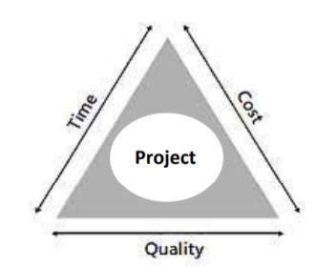

**Project Resource:**

* In order to improve the application, so that they become more efficient and productive and therefore finishing the project on Time and at the required level of Quality, a control system of each resource should be prepared.

**Project Participants:**

* Each project, whatever is its type or what kind of construction involves, requires the participation of three main parties.
* These participants are the Owner, Engineer/Designer, and Contract.
* In addition to these main participants, there are other sub-players, such as Consultants, Suppliers, Sub-contractors, and many others.
* They are working together under the role of the Project Manager in order to deliver the project’s final product.

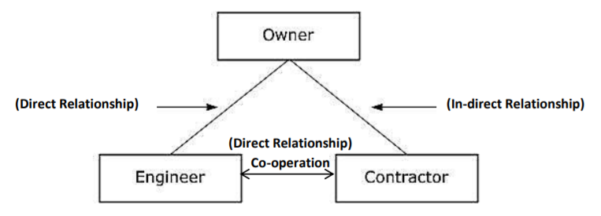

**Types of Construction Projects:**

* **Agricultural:** Typically economical buildings, and other improvements, for agricultural purposes. Examples include barns, equipment and animal sheds, specialized fencing, storage [silos](https://en.wikipedia.org/wiki/Silo) and [elevators](https://en.wikipedia.org/wiki/Elevator), and water supply and drains such as wells, tanks, and ditches.
* **Residential:** Residential construction includes houses, apartments, townhouses, and other smaller, low-rise housing, small office types.
* **Commercial:** This refers to construction for the needs of private commerce, trade, and services. Examples include office buildings, "big box" stores, shopping centres and malls, warehouses, banks, theatres, casinos, resorts, golf courses, and larger residential structures such as high-rise hotels and condominiums.
* **Institutional:** This category is for the needs of government and other public organizations. Examples include schools, fire and police stations, libraries, museums, dormitories, research buildings, hospitals, transportation terminals, some military facilities, and governmental buildings.
* **Industrial:** Buildings and other constructed items used for storage and product production, including chemical and power plants, steel mills, oil refineries and platforms, manufacturing plants, pipelines, and seaports.
* **Heavy civil:** The construction of transportation [infrastructure](https://en.wikipedia.org/wiki/Infrastructure) such as roads, bridges, railroads, tunnels, airports, and fortified military facilities. Dams are also included, but most other water-related infrastructure is considered environmental.
* **Environmental:** Environmental construction was part of heavy civil, but is now separate, dealing with projects that improve the environment. Some examples are water and wastewater treatment plants, sanitary and storm sewers, solid waste management, and air pollution control.

**Project Manager:**

* A project manager is a professional in the field of [project management](https://en.wikipedia.org/wiki/Project_management). Project managers have the responsibility of the planning, [procurement](https://en.wikipedia.org/wiki/Procurement) and execution of a [project](https://en.wikipedia.org/wiki/Project), in any undertaking that has a defined scope, defined start and a defined finish; regardless of industry.
* Project managers are first point of contact for any issues or discrepancies arising from within the heads of various departments in an organization before the problem escalate to higher authorities.

**Responsibilities:**

* Developing the [project plans](https://en.wikipedia.org/wiki/Project_plan)
* Managing the [project stakeholders](https://en.wikipedia.org/wiki/Project_stakeholders)
* [Managing communication](https://en.wikipedia.org/wiki/Communications_management)
* Managing the project team
* [Managing the project risks](https://en.wikipedia.org/wiki/Project_risk_management)
* Managing the project [schedule](https://en.wikipedia.org/wiki/Schedule_(project_management))
* [Managing the project budget](https://en.wikipedia.org/wiki/Project_cost_management)
* Managing the project conflicts
* Managing the project delivery

**Project Life Cycle:**

**Project Initiation**

* Initiation is the first phase of the project lifecycle. This is where the project’s value and feasibility are measured.
* **Business Case Document** – This document justifies the need for the project, and it includes an estimate of potential financial benefits.
* **Feasibility Study** – This is an evaluation of the project’s goals, timeline and costs to determine if the project should be executed. It balances the requirements of the project with available resources to see if pursuing the project makes sense.
* Teams abandon proposed projects that are labeled unprofitable and/or unfeasible. However, projects that pass these two tests can be assigned to a project team or designated project office.

**Project Planning**

* Once the project receives the green light, it needs a solid plan to guide the team, as well as keep them on time and on budget.
* A well-written project plan gives guidance for obtaining resources, acquiring financing and procuring required materials.
* The project plan gives the team direction for producing quality outputs, handling risk, creating acceptance, communicating benefits to stakeholders and managing suppliers.
* The project plan also prepares teams for the obstacles they might encounter over the course of the project, and helps them understand the cost, scope and timeframe of the project.

**Project Execution**

* This is the phase that is most commonly associated with project management. Execution is all about building deliverables that satisfy the customer.
* Team leaders make this happen by allocating resources and keeping team members focused on their assigned tasks.
* Execution relies heavily on the planning phase. The work and efforts of the team during the execution phase are derived from the project plan.

**Project Monitoring and Control**

* Monitoring and control are sometimes combined with execution because they often occur at the same time.
* As teams execute their project plan, they must constantly monitor their own progress.
* To guarantee delivery of what was promised, teams must monitor tasks to prevent scope creep, calculate key performance indicators and track variations from allotted cost and time.
* This constant vigilance helps keep the project moving ahead smoothly.

**Project Closure**

* Teams close a project when they deliver the finished project to the customer, communicating completion to stakeholders and releasing resources to other projects.
* This vital step in the project lifecycle allows the team to evaluate and document the project and move on the next one, using previous project mistakes and successes to build stronger processes and more successful teams.

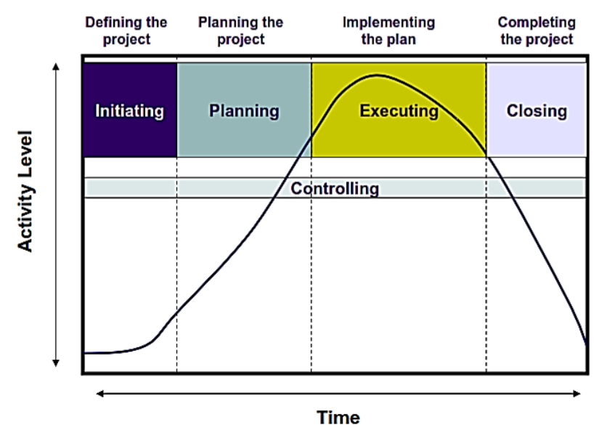

**Module: 2**

**Scheduling:**

Scheduling is laying out of the actual jobs of the project in the time order in which they have to be performed.

* Manpower and material requirements needed at each stage of construction are calculated, along with the expected completion time of each of the jobs.
* A schedule shows the starting and completion dates of each activity and the sequential relationship among the various activities.

**Need:**

* To predict project completion time.
* To control cost and resources.
* To serve as record
* To manages changes and uncertainties.

**Schedule Network Analysis:**

* The schedule network is a graphical display of all logical interrelationships between elements of work — in chronological order.
* This order is from initial planning through to project closure.
* As the project progresses, regular analysis of this network diagram are a check to ensure that the project is proceeding ‘on track’.

**Line of Balance Schedule Technique:**

* It is a planning technique for repetitive work.
* The essential procedure for this scheduling technique is to allocate the resources needed for each step or operation, so that the following activities are not delayed and the result can be obtained.

**Applications:**

* The principles employed are taken from the planning and control of manufacturing processes
* This process usually applied in the construction work and more specific in road construction.
* It is very powerful and easy to use process when the conditions are ideal for this type of work.

**Work Breakdown Structure (WBS):**

* Systematic and logical breakdown the project into its components and sub-components in hierarchical order is called work breakdown structure.
* It is constructed by dividing a project into major components, each of which is further sub-divided into smaller components.
* The process is continued till a breakdown accomplishes the manageable unit of works for which responsibility can be defined.

Work breakdown is the first and major step in planning and the execution of the project. The level of smaller component should be such that each of which should be:

* Manageable so that responsibility can be assigned.
* Independent so that there is minimum dependence on other ongoing activities.
* Integrable so that total package can be seen, and
* Measurable so progress can be measured.

**Advantage:**

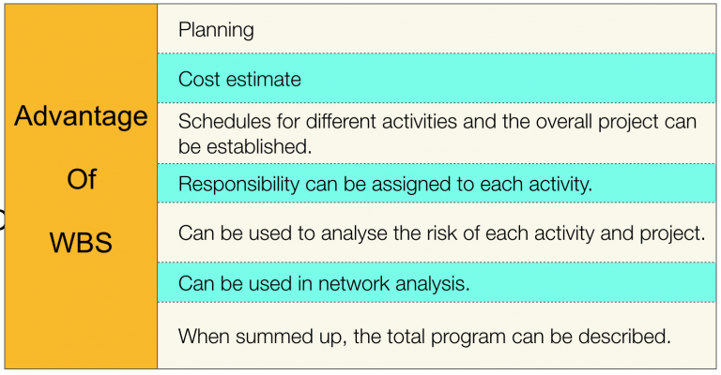

**Disadvantage:**

* Requires active management of interfaces
* Increased work burdens on management and management functions like planning, organising, monitoring, and review
* Potential demarcation problems

**Bar Chart/ Gantt Chart:**

* A bar chart is also called a Gantt chart since it was developed by Henry Gantt in 1920s.
* It is one of the most popular and widely used techniques for planning and scheduling activities because the graphical representation of a bar chart makes it easy to read and understand.
* The plan laid out when the GANTT Chart was created can be compared with actual times taken (plotted below the planned time bars in the chart).

**Properties:**

* This is a horizontal bar chart plotted over time (e.g. days, weeks or months).
* Each activity is shown as a bar (its length based on a time estimate).
* Depending on task dependencies and resource availability, these bars may be sequential, or run in parallel.
* Each bar is plotted to start at the earlier possible start date.
* Bar charts are useful and used to detect the amount of resources needed for one particular project.
* Resource aggregation is done by adding resources vertically in the schedule.
* The purpose of this aggregation is to estimate the work production and establishing estimates for man-hour and equipment needed.

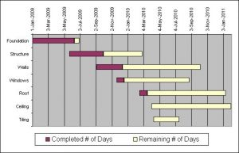

**Advantages:**

* It is simple to understand.
* Easy to prepare, consume less resources.
* Easy to develop and implement, no training is required.
* It can be used to show progress.
* Appropriate for small projects.
* Can be used for resources schedule.
* It gives the clear pictorial model of the project.

**Shortcomings:**

* Difficult to construct Bar chart for the large and complex project due to limitations of the size of paper.
* The relationship between activities cannot be shown easily.
* Difficult to find critical path, critical activities, and floats etc.
* Difficulties in seeing immediately and exactly overall project duration if changes occur in any particular activity.
* It cannot be used as control device
* Long duration project may seem to be most important which may not be correct.
* Difficult to manipulate and make corrections i.e. updating means to redraw the entire chart again.

**Linked Bar Chart:**

* A variation of the bar chart schedule.
* A linked bar chart uses arrows and lines to tie the activities and subsequent items, specifying the successors and predecessors of every activity.
* The previous activities are linked one to another to demonstrate that one activity must be completed before the other activity can start.
* The linked bar chart has an advantage of exhibiting the effect of delay on succeeding activities and also it can provide some information of the extra time available (if there is) with an activity for its completion.
* The extra time available for an activity for its completion is called float.
* Similarly, the activities, which do not have extra time for completion, are called critical activities.

**Milestone Chart:**

* Milestone Chart is an improved version of a bar chart.
* It is called Gantt Milestone Chart.

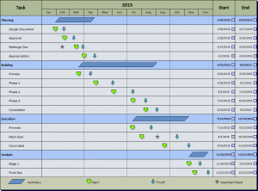

* Combined activity bar charts can be converted to milestone bar charts by placing small triangles or circles or a flag at strategic locations in the bars to indicate completion of certain milestones within each activity or group of activities.
* A milestone implies some specific stage or point where major activity either begins or ends, or cost data become critical.
* Each bar in a milestone chart again represents an activity or job or task and all the bars took together represent the entire project.

**Module: 3**

**Network Analysis:**

Network Analysis methods is a group of special analytical methods that are used in case where it is necessary to analyze and optimize a network of interconnected and related elements that have some connection between one another.

**Network Diagram:**

The network analysis methods are related to the concept of **network diagram**, which is a view of the project as a diagram which expresses various links between the project activities. The network diagrams and network analysis methods are based on the Graph Theory.

**Activity (Task):**

* An activity is any identifiable job which requires time, manpower, material and other resources to complete.
* The arrow in a network diagram represents activity.

**Concurrent (parallel) activities**:

* This can be performed simultaneously and independently to each other.
* In the figure, A and B are concurrent activities.

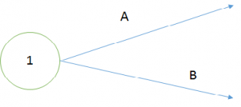

**Serial Activities**:

* Performed one after the other, in succession.
* In the figure below A and B are serial activities.

http://iesgeneralstudies.com/wp-content/uploads/2017/08/Ch3_serial_activities-300x43.png

**Activity duration:**

* An activity’s duration is estimated the time required for its completion.
* Time unit may be hours, days, weeks or months.
* Activity duration= Work quantity/Production rate

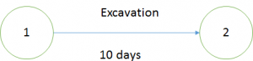

**Event (Node):**

* The beginning or end of the activity is known as event.
* It represents specific time and does not consume time manpower, material, and other resources.

http://iesgeneralstudies.com/wp-content/uploads/2017/08/Ch3_event_node-300x61.png

**Relationship between Events:**

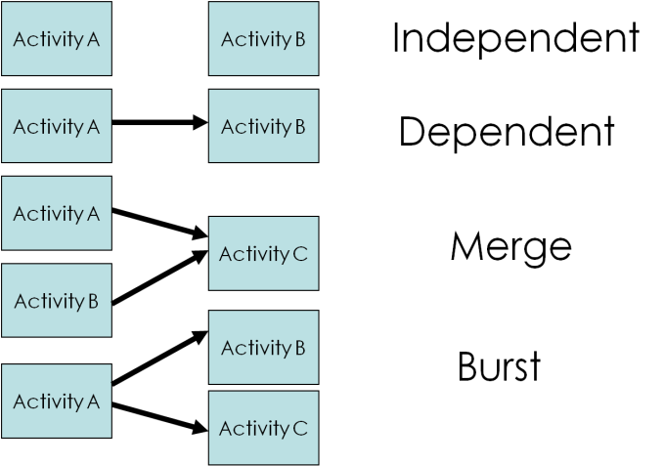 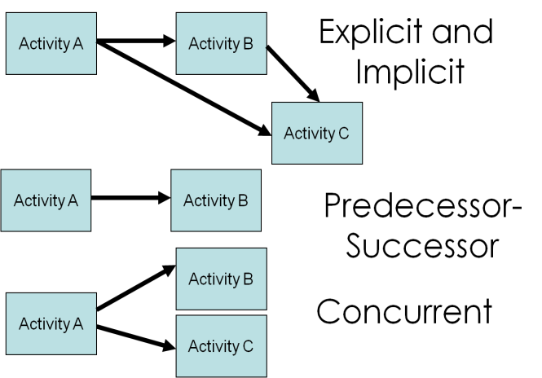

**Types of Activities on a Network:**

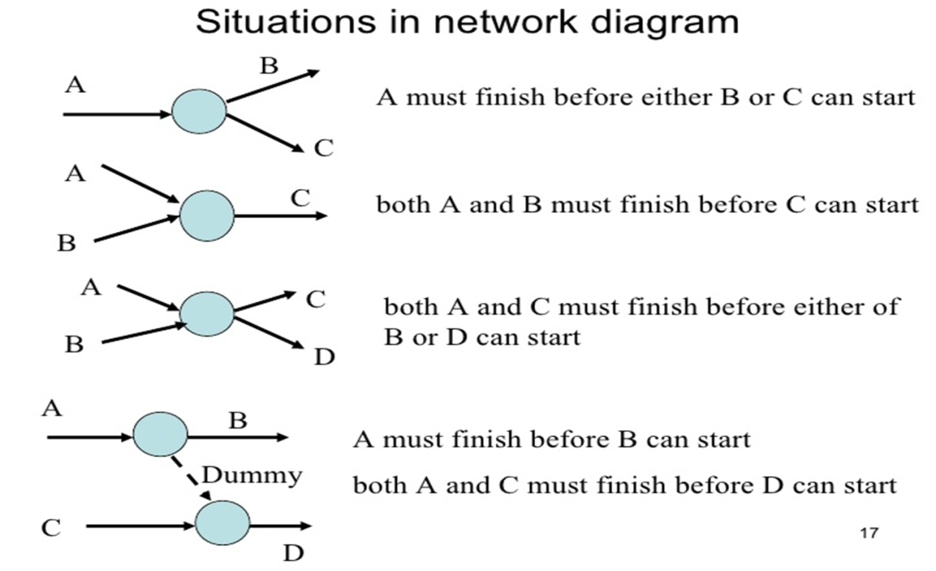

**Fulkerson Rule:**

* **Rule 1:** Each activity is represented by *one and only one arrow* in the network.
* **Rule 2:** No two activities can be identified by the same end events
* **Rule 3:** Precedence relationships among all activities must always be maintained.
* **Rule 4:** *Dummy activities* can be used to maintain precedence relationships only when actually required. Their use should be minimized in the network diagram
* **Rule 5:** Looping among the activities must be avoided.

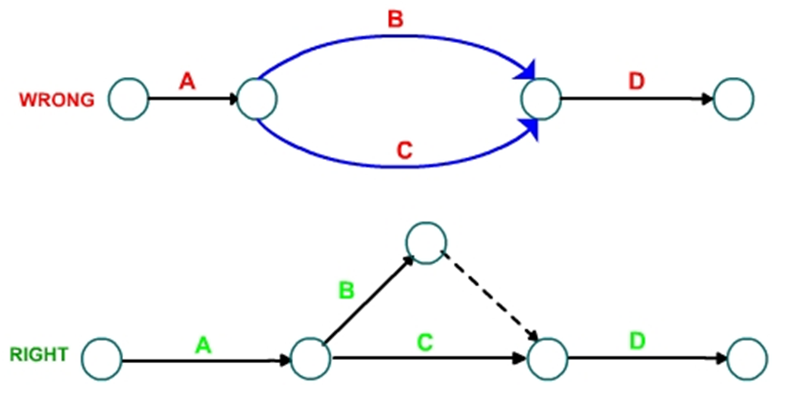

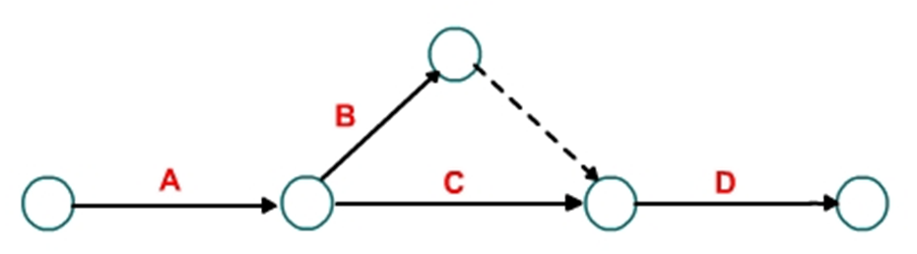

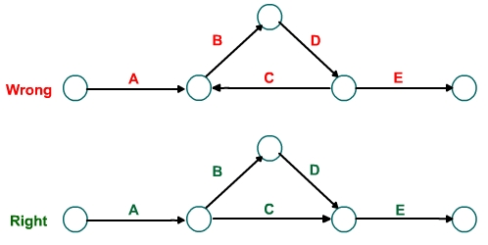

**Dummy Activity:**

* This doesn’t consume resources like time, cost, manpower, equipment etc.
* But is only used to show relationships.
* It is represented by Dashed Arrow.

Dummies serve two purposes in network:

* **Grammatical purpose:**
  + It is used to prevent two arrows having the common beginning and end nodes for two or more activities.
* **Logical purpose:**
  + Dummies are also used to give logical clear representation in the network having an activity common to two sets of operations running parallel to each other.

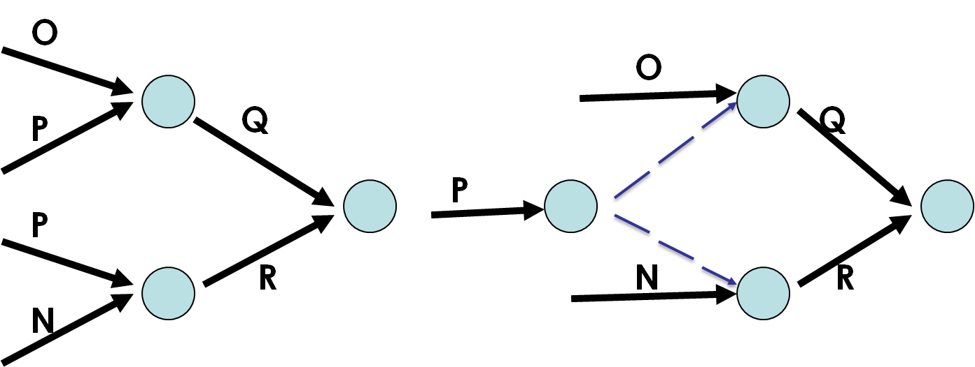

**Earliest Start time (ES):**

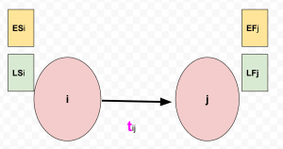

* It is the earliest possible time an activity or operation can be started.
* It is equal to the earliest occurrence time of the tail event of that activity. It is represented either EST or simply ESi

**Earliest Finish Time (EF)**:

* It is the earliest possible time for completion of an activity without delaying the project completion time.

EF= ES + duration

EFj=ESi+tij

**Latest Finish Time (LF)**:

* It is the latest time the activity must be completed without delaying project duration.
* It is equal to the latest occurrence time of the head event.

**Latest Start time (LS)**:

* It is the latest possible time; an activity can be started without delaying the project.

LS= LF – duration

LSi=LFj – tij

**Critical PathMethod:**

Unlike bar chart, it uses arrows to represent activities and length of arrows has no relation with activity duration. Start or end of an activity is called event and it is shown by circles with the special designation.

* Starting event is called tail event and ending event is called head event.
* Some event plays dual both the role of head and tail such events are called dual role events.
* Activity which must be completed before start of another activity is predecessor.
* Activity which starts after completion of an activity is its successor.
* Activity B is successor of activity A and activity A is predecessor of activity B.

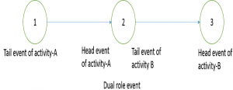

**Critical path**:

* The longest path in a CPM network is called critical path.
* There may be more than one critical path in a network.

**Project duration**:

* The time required to travel critical path is called project duration.

**Critical activities**:

* The activities lying on critical path are called critical activities.

**Floats**

* Float means the available free time for an activity, which is useful for managers to manage the limited resources.

An activity has four types of floats.

**Total Float (TF)**:

* It is the total free time for an activity i.e. maximum time by which completion of an activity can be delayedwithout affecting project completion time.
* Significance:
* It works as buffer time for managers, to meet contingencies like machine breakdown, labour absentism, etc.

TF= (LF-ES)-tij = ( LF-tij )- ES

                                                              = LS – ES

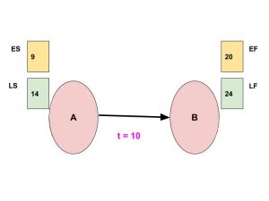

Example numerical:

Total float for this activity A-B is (LS – ES)  = (14 – 9) = 5

**Free Float (FF):**

* It is the spare time allowable for an activity so that the start time of succeeding activities are not affected.
* It is based on the possibility that all events occur at their earliest time.

FF = (EF -ES) – tij =EF – (ES+tij)

Numerical example:

Free float for the activity A-B is  = 20 – (9 + 10) = 20 – 19 = 1

**Independent Float (IF or Ind. Float)**:

* It is the maximum delay allowable for an activity so that the start time of succeeding activities are not affected.
* It may come negative but should be taken as zero.

IF = EF – LS – tij

Numerical example:

Independent float for the activity A-B is  = 20 – (14 + 10) = 20 – 24 = -4 (considered as 0)

**Interfering Float (Int. Float)**:

* It is name given to head event slack. It is the difference between TF & FF.

Int. Float= TF – FF

Interfering float for the activity A-B is  = 5 – 4 = 1

**Characteristics of critical path:**

* It is the longest path of activities.
* It determines the total project duration.
* There may be more than one Critical Path in a network.
* A Critical Path may consist of less no. of activities than Non-critical Path.
* The Critical Activities demand the requirement of resources prior to other activities to complete the project in time.

**Significance of critical path:**

* If there is any delay in either starting or if the time taken to complete critical activity exceeds the estimated time, project implementation period will get extended.
* Thus, any delay in critical activities leads to time overrun of the project which ultimately results in cost overrun.

**Advantages:**

* Makes dependencies visible.
* Organizes large and complex project.
* Enables the calculation of float of each activity.
* Encourages the project manager to reduce project duration.
* Increases visibility of the impact of schedule revisions.
* Provides opportunities to respond to the negative risk going over-schedule.

**Shortcomings:**

* In large and complex projects, there will be thousands of activities and dependency relationships.
* This method doesn’t account for resource and resource allocation.

**Module: 4**

**Programming Evaluation and Review Technique (PERT):**

The program (or project) evaluation and review technique (PERT) is a statistical tool used in [project management](https://en.wikipedia.org/wiki/Project_management), which was designed to analyze and represent the [tasks](https://en.wikipedia.org/wiki/Task_(project_management)) involved in completing a given [project](https://en.wikipedia.org/wiki/Project).

PERT has defined four types of time required to accomplish an activity:

* **Optimistic time**: the minimum possible time required to accomplish an activity (o) or a path (O), assuming everything proceeds better than is normally expected
* **Pessimistic time:** the maximum possible time required to accomplish an activity (p) or a path (P), assuming everything goes wrong (but excluding major catastrophes).
* **Most likely time:** the best estimate of the time required to accomplish an activity (m) or a path (M), assuming everything proceeds as normal.
* **Expected time:** the best estimate of the time required to accomplish an activity (te) or a path (TE), accounting for the fact that things don't always proceed as normal (the implication being that the expected time is the average time the task would require if the task were repeated on a number of occasions over an extended period of time).

**te** = (**o** + **4m** + **p**) ÷ **6**

* **Standard deviation of time :** the variability of the time for accomplishing an activity (σte) or a path (σTE)

**σte** = (**p** - **o**) ÷ **6**

{\displaystyle \sigma _{TE}={\sqrt {\sum _{i=1}^{n}{\sigma _{te_{i}}}^{2}}}}

**Difference between PERT & CPM:**

|  |  |
| --- | --- |
| * CPM uses activity oriented network. | * PERT uses event oriented Network. |
| * Durations of activity may be estimated with a fair degree of accuracy. | * Estimate of time for activities are not so accurate and definite. |
| * It is used extensively in construction projects. | * It is used mostly in research and development projects, particularly projects of non-repetitive nature. |
| * Deterministic concept is used. | * Probabilistic model concept is used. |
| * CPM can control both time and cost when planning. | * PERT is basically a tool for planning. |
| * In CPM, cost optimization is given prime importance. The time for the completion of the project depends upon cost optimization. The cost is not directly proportioned to time. Thus, cost is the controlling factor. | * In PERT, it is assumed that cost varies directly with time. Attention is therefore given to minimize the time so that minimum cost results. Thus in PERT, time is the controlling factor. |

**Time Estimation:**

Make sure that you also allow time for project management administration, detailed project, liaison with outside bodies’ resources and authorities, meetings, quality assurance developing supporting documentation or procedures necessary, and training.

Also make sure that you have allowed time for:

* Other high urgency tasks to be carried out which will have priority over this one.
* Accidents and emergencies.
* Internal/external meetings.
* Holidays and sickness in key staff/stakeholders.
* Contact with other customers, suppliers and contractors.
* Breakdowns in equipment.
* Missed deliveries by suppliers.
* Interruptions by customers, suppliers, contractors, family, pets, co-workers, etc.
* Others priorities and schedules e.g. local government planning processes.
* Quality control rejections, etc.
* Unanticipated events (e.g. renovating the bathroom finding white-ants/termites in the walls).

**Slack:**

Slack time, used in [Program Evaluation and Review Technique (PERT)](https://www.brighthubpm.com/project-planning/4997-using-a-pert-chart/), denotes how much an activity can be delayed beyond its earliest start date, without causing any problems in the completion of the project by its due date. Also known as float, slack time is applicable only to those activities which do not lie on the critical path of the PERT chart. For all activities that lie on the critical path the earliest start time will be the same as latest start time and the earliest finish time will be the same as latest finish time.

Calculating the slack time for an activity in a PERT chart is very easy and does not involve any complex calculations. There are two things that are needed to calculate the slack time:

1. ES – the earliest time when an activity can be started
2. LS – The latest time when an activity must be started

The slack time is calculated as:

Slack Time = LS-ES

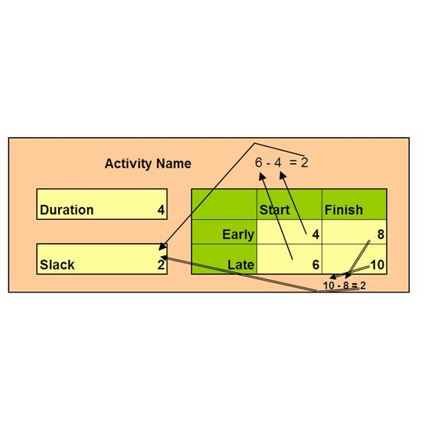

Alternatively, slack time can also be calculated as the difference between the latest finish time and the early finish time. Slack time must be calculated for all activities involved in the project. Calculating the slack time [is another way of tracing the critical path](https://www.brighthub.com/office/project-management/articles/49584.aspx) on a PERT chart. All activities which return a ZERO as the slack time, are the critical activities.

Slack time is a very integral part of the project process and it must be [clearly shown on the PERT chart](https://www.brighthubpm.com/templates-forms/36049-creating-pert-charts-in-excel-2007/). Ignoring slack time can lead to consequences that may compromise the overall performance and efficiency of the project. Only when the slack times have been identified will it be possible to use them to the project’s advantage.

**Slack and Float:**

The terms "slack" and "float" are often used interchangeably. However, the essential difference between the terms is that slack is typically associated with inactivity, while float is associated with activity. Slack time allows an activity to start later than originally planned, while float time allows an activity to take longer than originally planned.

**Calculation of Expected Time and Variance of a Path in PERT:**

The Expected Time of a chain of activities in series, is the sum of their expected times. Similarly the variance of the path, is the sum of variances of activities on the path. In Figure below, three activities A,B and C are connected in series, (i.e. form a path). Their time estimates ***to-tm-tp***are given along the activity arrows. The expected time of the path 1-2-3-4 is calculated as:

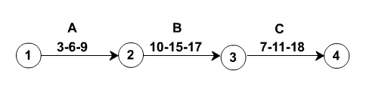

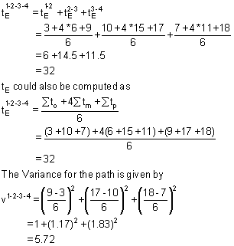

As the length of the path, that is the number of activities connected in series increases, the variance of the path and hence the uncertainty of meeting the expected time also increases.

**Example:**

In the network of figure below, the PERT time estimates of the activities are written along the activity arrows in the order ***to-tm-tp.***Compute the expected time and variance for each activity. Also compute the expected duration and standard deviation for the following paths of the network.

           (a) 10-20-50-80-90

           (b) 10-30-50-70-90

           (c) 10-40-60-80-90

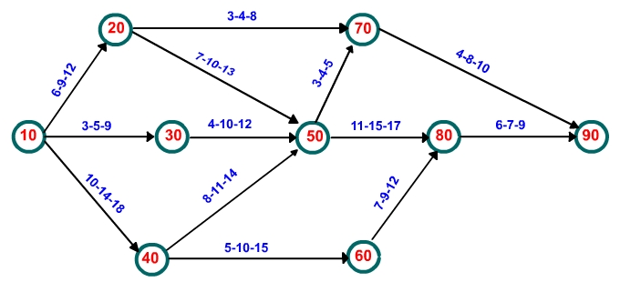

The computation of expected times and variances for different activities are carried in a table given below.

|  |  |  |  |
| --- | --- | --- | --- |
| **Activity**  **i              j** | **Time Estimates**  **to           tm          tp** | **Expected Time**  **tE** | **Variance**  **σ2** |
| 10           20 | 6             9           12 | 9.00 | 1.00 |
| 10           30 | 3             5            9 | 5.33 | 1.00 |
| 10           40 | 10         14           18 | 14.00 | 1.78 |
| 20           50 | 7           10           13 | 10.00 | 1.00 |
| 20           70 | 3             4             8 | 4.5 | 0.69 |
| 30           50 | 4           10           12 | 9.33 | 1.78 |
| 40           50 | 8           11           14 | 11.00 | 1.00 |
| 40           60 | 5          10           15 | 10.00 | 2.78 |
| 50           70 | 3            4            5 | 4.00 | 0.11 |
| 50           80 | 11           15          17 | 14.67 | 1.00 |
| 60           80 | 7             9           12 | 9.17 | 0.69 |
| 70           90 | 4             8            10 | 7.67 | 1.00 |
| 80           90 | 6             7           9 | 7.17 | 0.25 |

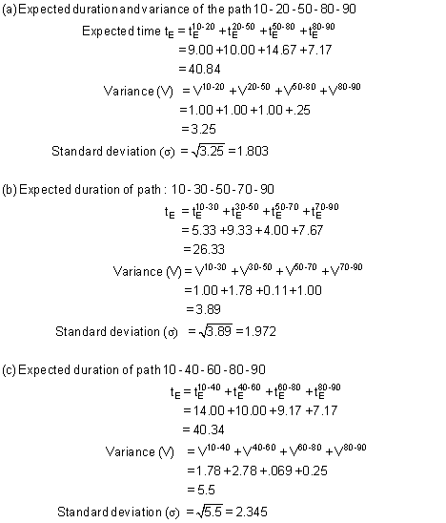

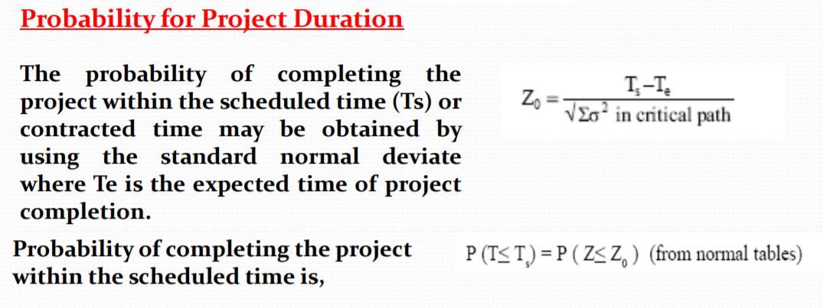

**Module: 5**

**Project alternative selection technique:**

There are two categories of project selection methods:

* Benefit Measurement Methods
* Constrained Optimization Methods

**Benefit Measurement Methods:**

Benefit Measurement is a project selection technique based on the present value of estimated cash outflow and inflow. Cost benefits are calculated and then compared to other projects to make a decision.

The techniques that are used in Benefit Measurement are as follows:

**Benefit/Cost Ratio**

* Cost/Benefit Ratio, as the name suggests, is the ratio between the Present Value of Inflow or the cost invested in a project to the Present Value of Outflow, which is the value of return from the project. Projects that have a higher Benefit Cost Ratio or lower Cost Benefit Ratio are generally chosen over others.

**Economic Model**

* EVA, or Economic Value Added, is the performance metric that calculates the worth-creation of the organization while defining the return on capital. It is also defined as the net profit after the deduction of taxes and capital expenditure.
* If there are several projects assigned to a project manager, the project that has the highest Economic Value Added is picked. The EVA is always expressed in numerical terms and not as a percentage.

**Scoring Model**

* The scoring model is an objective technique: the project selection committee lists relevant criteria, weighs them according to their importance and their priorities, then adds the weighted values. Once the scoring of these projects is completed, the project with the highest score is chosen.

**Payback Period**

* Payback Period is the ratio of the total cash to the average per period cash. It is the time necessary to recover the cost invested in the project. The Payback Period is a basic project selection method. As the name suggests, the payback period takes into consideration the payback period of an investment.  It is the time frame that is required for the return on an investment to repay the original cost that was invested.

**Constrained Optimization Methods:**

Constrained Optimization Methods, also known as the Mathematical Model of Project Selection, are used for larger projects that require complex and comprehensive mathematical calculations.

The techniques that are used in Constrained Optimization Methods are as follows:

**Non-Financial Considerations**

* There are non-financial gains that an organization must consider; these factors are related to the overall organization goals. The organizational strategy is a major factor in project selection methods that will affect the organization’s choice in the choice of project. Customer service relationships are chief among these organizational goals. An important necessity in today’s business world is to build effective, cordial customer relationships.

**Time-Money Concept:**

**Present Value** - An amount of money today, or the current value of a future cash flow

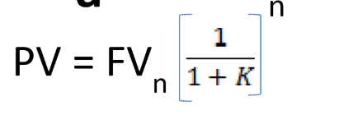

**Future Value** - An amount of money at some future time period

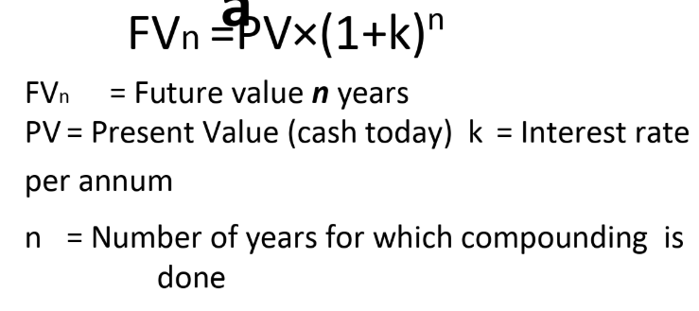 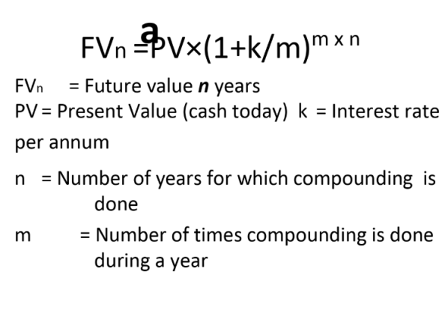

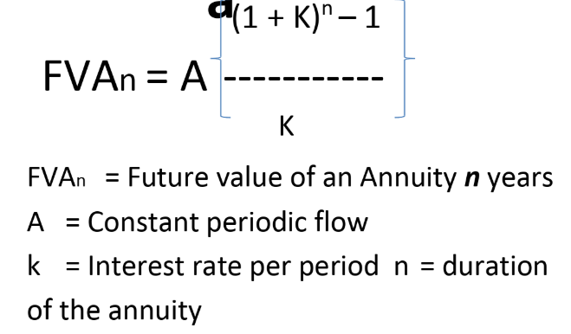

**Period** - A length of time (often a year, but can be a month, week, day, hour, etc.)

**Interest Rate** - The compensation paid to a lender (or saver) for the use of funds expressed as a percentage for a period (normally expressed as an annual rate)

**Compounding vs. Simple Interest:**

Compounding interest is defined as earning interest on interest.

Simple interest is interest earned on the principal investment.

Principal refers to the original amount of money invested or saved

**Effective Rate of Interest:**

Effective Interest rate: The percentage rate of return on an annual basis. It reflects the effect of intra-year compounding. (Ex. 12.36%)

Nominal Interest rate: Interest rate expresses in monitory terms. (Ex. 12%)

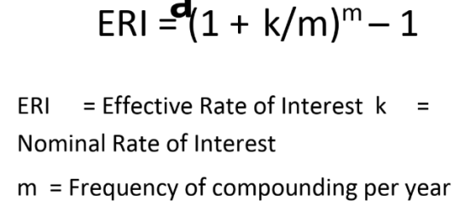

**Capital Budgeting:**

Capital budgeting is the process in which a business determines and evaluates potential large expenses or investments. These expenditures and investments include projects such as building a new plant or investing in a long-term venture. Often, a company assesses a prospective project's lifetime cash inflows and outflows to determine whether the potential returns generated meet a sufficient target [benchmark](https://www.investopedia.com/terms/b/benchmark.asp), also known as "investment [appraisal](https://www.investopedia.com/terms/a/appraisal.asp)."

**Net Present Value (NVP):**

Net present value (NPV) is the difference between the present value of cash inflows and the present value of cash outflows over a period of time. NPV is used in [capital budgeting](https://www.investopedia.com/terms/c/capitalbudgeting.asp) and investment planning to analyze the profitability of a projected investment or project.

The following is the formula for calculating NPV:

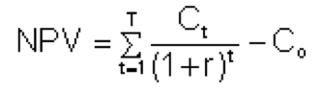

Where:

Ct = net cash inflow during the period t

Co= total initial investment costs

r = discount rate, and

t = number of time periods

**NPV = (Today’s value of the expected cash flows) – (Today’s value of invested cash)**

A positive net present value indicates that the projected earnings generated by a project or investment (in present dollars) exceed the anticipated costs (also in present dollars).

It is assumed that an investment with a positive NPV will be profitable, and an investment with a negative NPV will result in a net loss. This concept is the basis for the [Net Present Value Rule](https://www.investopedia.com/terms/n/npv-rule.asp), which dictates that only investments with positive NPV values should be considered.

**Internal Rate of Return (IRR):**

Internal rate of return (IRR) is a metric used in [capital budgeting](https://www.investopedia.com/terms/c/capitalbudgeting.asp) to estimate the profitability of potential investments. Internal rate of return is a [discount rate](https://www.investopedia.com/terms/d/discountrate.asp) that makes the [net present value](https://www.investopedia.com/terms/n/npv.asp) (NPV) of all cash flows from a particular project equal to zero.

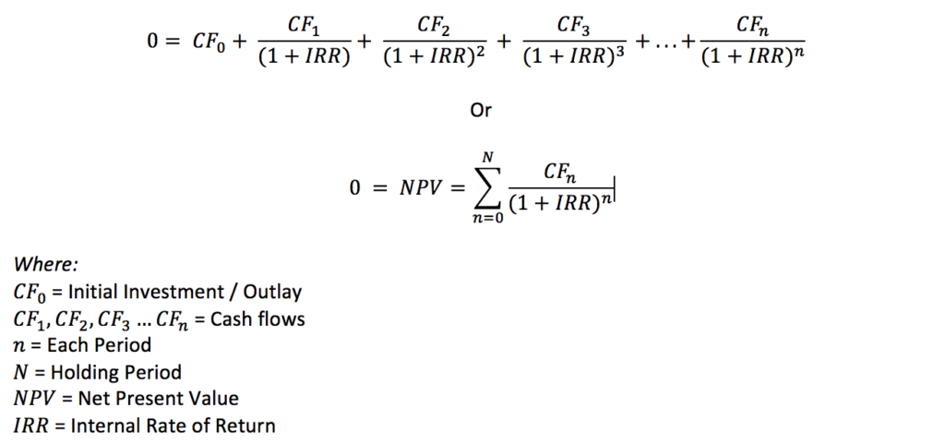

To calculate IRR using the formula, one would set NPV equal to zero and solve for the discount rate (r), which is the IRR. Because of the nature of the formula, however, IRR cannot be calculated analytically and must instead be calculated either through trial-and-error or using software programmed to calculate IRR.

**Relevance of IRR:**

In theory, any project with an IRR greater than its cost of capital is a profitable one, and thus it is in a company’s interest to undertake such projects. In planning investment projects, firms will often establish a [required rate of return](https://www.investopedia.com/terms/r/requiredrateofreturn.asp) (RRR) to determine the minimum acceptable return percentage that the investment in question must earn in order to be worthwhile.

Any project with an IRR that exceeds the RRR will likely be deemed a profitable one, although companies will not necessarily pursue a project on this basis alone. Rather, they will likely pursue projects with the highest difference between IRR and RRR, as these likely will be the most profitable.

**Issues with IRR:**

While IRR is a very popular metric in estimating a project’s profitability, it can be misleading if used alone. Depending on the initial investment costs, a project may have a low IRR but a high NPV, meaning that while the pace at which the company sees returns on that project may be slow, the project may also be adding a great deal of overall value to the company.

**Difference Between NVP & IRR:**

| **BASIS FOR COMPARISON** | **NPV** | **IRR** |
| --- | --- | --- |
| Meaning | The total of all the present values of cash flows (both positive and negative) of a project is known as Net Present Value or NPV. | IRR is described as a rate at which the sum of discounted cash inflows equates discounted cash outflows. |
| Expressed in | Absolute terms | Percentage terms |
| What it represents? | Surplus from the project | Point of no profit no loss (Break even point) |
| Decision Making | It makes decision making easy. | It does not help in decision making |
| Rate for reinvestment of intermediate cash flows | Cost of capital rate | Internal rate of return |
| Variation in the cash outflow timing | Will not affect NPV | Will show negative or multiple IRR |

**Benefit-Cost Ratio:**

A **benefit-cost ratio** (BCR) is an indicator, used in [cost-benefit analysis](https://en.wikipedia.org/wiki/Cost-benefit_analysis), that attempts to summarize the overall [value for money](https://en.wikipedia.org/wiki/Value_(economics)) of a project or proposal.

A BCR is the ratio of the benefits of a project or proposal, expressed in monetary terms, relative to its costs, also expressed in monetary terms. All benefits and costs should be expressed in discounted [present values](https://en.wikipedia.org/wiki/Present_value).

A BCR can be a [profitability index](https://en.wikipedia.org/wiki/Profitability_index) in for-profit contexts. Benefit cost ratio (BCR) takes into account the amount of monetary gain realized by performing a project versus the amount it costs to execute the project.

The higher the BCR the better the investment. General rule of thumb is that if the benefit is higher than the cost the project is a good investment.

**BCR = Discounted value of incremental benefits ÷ Discounted value of incremental costs**

Accept all projects with a BCR greater than 1, when costs and benefits are discounted at the opportunity cost of capital.

**Break-Even Analysis:**

The **break-even point** (BEP) in [economics](https://en.wikipedia.org/wiki/Economics), [business](https://en.wikipedia.org/wiki/Business)—and specifically [cost accounting](https://en.wikipedia.org/wiki/Cost_accounting)—is the point at which total cost and total revenue are equal, i.e. "even". There is no net loss or gain, and one has "broken even", though [opportunity costs](https://en.wikipedia.org/wiki/Opportunity_cost) have been paid and capital has received the risk-adjusted, expected return. In short, all costs that must be paid are paid, and there is neither profit nor loss.

In the linear [Cost-Volume-Profit Analysis](https://en.wikipedia.org/wiki/Cost-Volume-Profit_Analysis) model (where marginal costs and marginal revenues are constant, among other assumptions), the **break-even point (BEP)** (in terms of Unit Sales (X)) can be directly computed in terms of Total Revenue (TR) and Total Costs (TC) as:

{\displaystyle {\begin{aligned}{\text{TR}}&={\text{TC}}\\P\times X&={\text{TFC}}+V\times X\\P\times X-V\times X&={\text{TFC}}\\\left(P-V\right)\times X&={\text{TFC}}\\X&={\frac {\text{TFC}}{P-V}}\end{aligned}}} 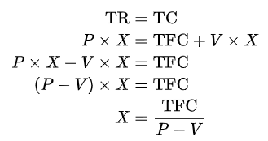

Where:

* **TFC** is **Total**[**Fixed Costs**](https://en.wikipedia.org/wiki/Fixed_Costs),
* **P** is **Unit Sale Price**, and
* **V** is **Unit Variable Cost**.

The quantity, (P-V){\displaystyle \left(P-V\right)}, is of interest in its own right, and is called the [Unit Contribution Margin](https://en.wikipedia.org/wiki/Contribution_margin) (C): it is the marginal profit per unit, or alternatively the portion of each sale that contributes to Fixed Costs. Thus the break-even point can be more simply computed as the point where Total Contribution = Total Fixed Cost:

{\displaystyle {\begin{aligned}{\text{Total Contribution}}&={\text{Total Fixed Costs}}\\{\text{Unit Contribution}}\times {\text{Number of Units}}&={\text{Total Fixed Costs}}\\{\text{Number of Units}}&={\frac {\text{Total Fixed Costs}}{\text{Unit Contribution}}}\end{aligned}}}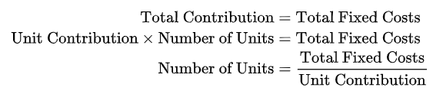

To calculate the break-even point in terms of revenue (a.k.a. currency units, a.k.a. sales proceeds) instead of Unit Sales (X), the above calculation can be multiplied by Price, or, equivalently, the Contribution Margin Ratio (Unit Contribution Margin over Price) can be calculated:

{\displaystyle {\text{Break-even(in Sales)}}={\frac {\text{Fixed Costs}}{C/P}}.}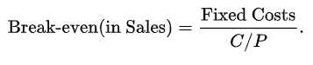

R=C,

Where R is revenue generated, C is cost incurred i.e. Fixed costs + Variable Costs or

{\displaystyle {\begin{aligned}Q\times P&=\mathrm {TFC} +Q\times VC&{\text{(Price per unit)}}\\Q\times P-Q\times \mathrm {VC} &=\mathrm {TFC} \\Q\times (P-\mathrm {VC} )&=\mathrm {TFC} \\\end{aligned}}}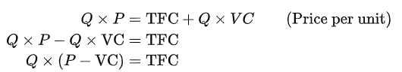

or, Break Even Analysis

Q = TFC/c/s ratio = Break Even

**Limitation:**

* The Break-even analysis is only a supply-side (i.e., costs only) analysis, as it tells you nothing about what sales are actually likely to be for the product at these various prices.
* It assumes that fixed costs (FC) are constant. Although this is true in the short run, an increase in the scale of production is likely to cause fixed costs to rise.
* It assumes average variable costs are constant per unit of output, at least in the range of likely quantities of sales. (i.e., linearity).
* It assumes that the quantity of goods produced is equal to the quantity of goods sold (i.e., there is no change in the quantity of goods held in inventory at the beginning of the period and the quantity of goods held in inventory at the end of the period).
* In multi-product companies, it assumes that the relative proportions of each product sold and produced are constant (i.e., the sales mix is constant).

**Project Monitoring Technique:**

**Work Breakdown Structure:**

* A work-breakdown structure (WBS) in [project management](https://en.wikipedia.org/wiki/Project_management) and [systems engineering](https://en.wikipedia.org/wiki/Systems_engineering), is a [deliverable](https://en.wikipedia.org/wiki/Deliverable)-oriented breakdown of a project into smaller components.
* A work breakdown structure is a key project deliverable that organizes the team's [work](https://en.wikipedia.org/wiki/Work_(project_management)) into manageable sections.
* The [Project Management Body of Knowledge](https://en.wikipedia.org/wiki/Project_Management_Body_of_Knowledge) defines the work-breakdown structure "A hierarchical decomposition of the total [scope](https://en.wikipedia.org/wiki/Scope_(project_management)) of work to be carried out by the [project team](https://en.wikipedia.org/wiki/Project_team) to accomplish the project objectives and create the required deliverables."
* A work-breakdown structure element may be a [product](https://en.wikipedia.org/wiki/Product_(business)), [data](https://en.wikipedia.org/wiki/Data), [service](https://en.wikipedia.org/wiki/Service_(economics)), or any combination thereof.
* A WBS also provides the necessary framework for detailed cost estimating and control along with providing guidance for [schedule](https://en.wikipedia.org/wiki/Schedule_(project_management)) development and control.

**Progress Curve or S-Curve:**

An S-curve is a project management tool that tracks progress over time and allows for a quick visual to determine project status. As the project continues and the S-curve grows, the graph will turn into a historical representation and allow for quick comparison to actual data.

**Example of an S-Curve**

|  |
| --- |
| s curve |
|  |
|  |

**Example of a Comparison S-Curve**

|  |
| --- |
| labor |

**Project Costs - Under Budget**

|  |
| --- |
| under |

**Project Costs - Over Budget**

|  |
| --- |
| over |

**Line of Balance:**

Line of Balance (LOB) is a management control process for collecting, measuring and presenting facts relating to time (see [Schedule Control](http://acqnotes.com/acqNote/schedule-control)), cost and accomplishment – all measured against a specific plan. It shows the process, status, background, timing and phasing of the project activities, thus providing management with measuring tools that help:

* Comparing actual progress with a formal objective plan.
* Examining only the deviations from established plans, and gauging their degree of severity with respect to the remainder of the project.
* Receiving timely information concerning trouble areas and indicating areas where appropriate corrective action is required.
* Forecasting future performance.

The LOB itself is a graphic device that enables a manager to see at a single glance which activities of an operation are “in balance” – i.e., whether those which should have been completed at the time of the review actually are completed and whether any activities scheduled for future completion are lagging behind schedule.

The LOB chart comprises only one feature of the whole philosophy which includes numerous danger signal controls for all the various levels of management concerned.

To do LOB, the following is needed:

* A contract schedule, or objective chart;
* A production plan or lead-time chart for the production process itself;
* Control points cumulative inventories; and
* A program status chart on which to plot LOB and the cumulative quantities of units that have passed through the control points of the assembly/production process.

**Module: 6**

**Cost Estimation Models:**

**Cost estimation models** are mathematical [algorithms](https://en.wikipedia.org/wiki/Algorithm) or [parametric equations](https://en.wikipedia.org/wiki/Parametric_equations) used to estimate the costs of a product or project. The results of the models are typically necessary to obtain approval to proceed, and are factored into business plans, budgets, and other financial planning and tracking mechanisms.

These algorithms were originally performed manually but now are almost universally computerized. They may be standardized (available in published texts or purchased commercially) or proprietary, depending on the type of business, product, or project in question. Simple models may use standard [spreadsheet](https://en.wikipedia.org/wiki/Spreadsheet) products.

**Direct costs:**

**Direct costs** are the expenses that are directly related to the project and can be measured with a relatively good degree of accuracy.

Many of the direct costs for James's project are fairly obvious, like the cost of materials for the manufacture of the hybrid vehicles.

These would be things such as raw materials, like steel and fiberglass,; finished components, like electronics, windshields and tires; and finishes, like paint, clear coating, and upholstery.

**Indirect Costs:**

**Indirect costs** are costs that help the company perform its activities but are not easily traceable to one specific project. Examples include the general expenses of doing business, such as rent, utilities, and office supplies.

Fringe benefits of the labourers manufacturing the cars are also considered indirect costs. This includes expenses like paid vacation and health insurance. All of these indirect costs are often referred to as **overhead costs** or **burden costs**.

**Cost Slope:**

**Normal time:** Normal time is the time required to complete the activity at normal conditions and cost.

**Crash time:** Crash time is the shortest possible activity time; crashing more than the normal time will increase the direct cost.

**Cost Slope:** The term '**cost**-**slope**' is defined as the “increase in the **cost** of the activity per unit decrease in the time”. In simple words, we can say that **cost slope** of an activity is the increase in **cost** of an activity by reducing the duration by one unit.

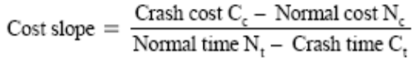

**Project Crashing:**

**Project crashing** is a method for shortening the**project** duration by reducing the time of one (or more) of the critical **project** activities to less than its normal activity time. This reduction in the normal activity time is referred to as **crashing**.

**Procedure for crashing**

* Step1: Draw the network diagram and mark the Normal time and Crash time.
* Step2: Calculate TE and TL for all the activities.
* Step3: Find the critical path and other paths.
* Step 4: Find the slope for all activities and rank them in ascending order.
* Step 5: Establish a tabular column with required field.
* Step 6: Select the lowest ranked activity; check whether it is a critical activity. If so,crash the activity, else go to the next highest ranked activity. Note: The critical path must remain critical while crashing.
* Step 7: Calculate the total cost of project for each crashing
* Step 8: Repeat Step 6 until all the activities in the critical path are fully crashed.

**Resource Usage Profile:**

Use the Resource Usage Profile to analyze quantity or cost usage for resources or roles. You can view a resource's or role's cost and quantity data for a specific project or for all projects across the enterprise (total allocation).

Define the profile to specify whether you want to display cost or quantity information and set the timescale for displaying data values. Choose to display past period actual or actual to date values in bars and curves. Choose to display vertical bars to represent costs or units allocated to your resources for each time period, and include cumulative curves to represent accumulated units and costs over time.

Use the Resource Usage Profile to

* Determine how many hours each resource is scheduled to work
* Identify overloaded resources
* Track expenditures per time period
* Determine resource usage by late dates
* Display a "banana" curve to compare early and late dates
* Display different colours or patterns on the histogram bars when showing the stacked histogram

**Histograms:**

A histogram is an accurate representation of the [distribution](https://en.wikipedia.org/wiki/Frequency_distribution) of numerical data. It is an estimate of the [probability distribution](https://en.wikipedia.org/wiki/Probability_distribution) of a [continuous variable](https://en.wikipedia.org/wiki/Continuous_variable) (quantitative variable) and was first introduced by Karl Pearson.

It differs from a [bar graph](https://en.wikipedia.org/wiki/Bar_graph), in the sense that a bar graph relates two variables, but a histogram relates only one.

To construct a histogram, the first step is to "[bin](https://en.wikipedia.org/wiki/Data_binning)" (or "[bucket](https://en.wikipedia.org/wiki/Data_binning)") the range of values—that is, divide the entire range of values into a series of intervals—and then count how many values fall into each interval.

The bins are usually specified as consecutive, non-overlapping [intervals](https://en.wikipedia.org/wiki/Interval_(mathematics)) of a variable. The bins (intervals) must be adjacent, and are often (but are not required to be) of equal size.

**Resource allocation:**

Resource allocation in project management is concerned with creating a plan which can help achieve future goals. There are many resources which have to be allocated when managing a project, beginning from budget to equipment and tools, to data and the project’s plan.

Resource allocation in project management is so important because it gives a clear picture on the amount of work that has to be done. It also helps to schedule ahead and have an insight into the team’s progress, including allocating the right amount of time to everyone on the team.

Resource allocation allows to plan and prepare for the project’s implementation or achieving goals. It is also possible to analyze existing [threats and risks](https://www.timecamp.com/blog/index.php/2018/02/positive-vs-negative-risk-in-project-management/) to the project.

But above all, resource allocation in project management helps to control all the workload. This, as a result, contributes to team’s effectiveness at work and what follows later is a satisfying and exhaustive project.

**Here’s**[**what you can do to allocate resources in the right way when managing a project**](https://www.projectmanager.com/blog/resource-allocation)**:**

* **Know the scope**– to know what is your project about, what you will need to achieve it, and to be able to properly allocate resources;
* **Identify resources –**to know which tools, equipment, etc. you will need it completing the project;
* **Track time**– to have a deep analysis of the progress and current situation as well as be able to control it in the real-time;
* **Don’t look only at the big picture –**the process of working on a project is not done with task allocation. Once you allocate resources you have to keep track of all of them. If you lose at least one tiny detail, your project may fail;
* **Don’t over-allocate –**because your team will experience burnout and their productivity will significantly drop.

**Resource levelling:**

“A technique in which start and finish dates are adjusted based on resource constraints with the goal of balancing demand for resources with the available supply.”

**Resource Smoothing:**

“A technique that adjusts the activities of a schedule model such that the requirements for resources on the project do not exceed certain predefined resource limits.”

**Differences between Resource Leveling and Resource Smoothing**

| **Resource leveling** | **Resource Smoothing** |
| --- | --- |
| It applies the resource constraints to the project and may result in change in project duration. | We apply resource smoothing after doing resource levelling and we make use of slack, and will not result in change of project duration. |
| Resource Levelling is primarily driven by resource constraints, like you do not have more than 45 hours of the given resource for a week. | Resource smoothing is more to do with desired limits, like we do have 45 hours available for given resource but we wish that we allocate 38 hours per week so we have some breathing space. |
| The allocation limits identified in resource leveling must be applied. | The desired limit identified in resource smoothing may not be applied in some cases, if we do not have slack. |
| The resource levelling is done first and then we do the resource smoothing. Since we need to first accommodate the resource constraints before we can optimize it. | We apply resource smoothing after applying resource levelling. |

**Project Updating:**

* **Baseline schedule**
* **Project in progress**
* Actual start
* **Actual and remaining duration**
* **Actual and remaining cost**
* **Remarks**

**Module: 7**

**Different types of Construction Equipments:**

Go through the images….

**Construction Safety requirements:**

**Major hazards of construction are:**

* Falls
* Electrocution
* Trenching & Excavation Hazard

**Falls:**

* Falls are the leading cause of fatalities in the construction industry
* Conditions that required use of fall protection
* A fall from as little as 4-6 feet
* Can cause loss of work
* In some cases death

**Prevention Technique:-**

* Safety Nets
* Hand Rails
* Safety Harness (PFAS)
* Equipment guards
* Fall protection systems must be in place before work start

**Electrocution:**

* Electricity is the flow of energy from one place to another.
* Requires a source of power (generating station, power station or portable generator).
* Travels in a close circuit.

**Prevention Technique:-**

* Always assume that all overhead wires are energized
* Never touch a down power line
* Never operate electrical equipment while standing in water
* Coming in contact with an electrical voltage can cause current to flow through the body, resulting in electrical shock and burns. Serious injury ***or even death***may occur.

**Trenching & Excavation Hazard:**

* Most hazardous construction operation
* Cave-ins are the greatest risk
* Most accidents occurred in
* 5-15 ft deep

**Prevention Technique:-**

* Employees should be protected from caves-in by using a well designed protective system
* Systems must be able to support expected loads to the system
* A well designed system will have a correct design of sloping and benching systems
* Correct design of support systems
* Handle materials and equipment

**Factors:-**

* Soil classification
* Depth of cut
* Water content of soil
* Changes due to weather and climate
* Other operations in the vicinity



**Factors Affecting Quality of Building Construction Projects:**

1. **Project**

* Scope of the project (type and nature)
* Location of the project
* Site access
* Period of the project

1. **Design**

* Completeness and consistency of design documents
* Drawings are prepared in full details
* Conformance to codes and standards
* Adherence to specifications
* Bill of quantity is detailed and accurate

1. **Contract**

* Cooperation between parties involved in contract
* Pervious successful relations between parties
* A written contract with clear conditions
* Using a standard contract
* Types of awarding system

1. **Material**

* Using a comprehensive material management system
* Cooperation between contractor and material suppliers
* Availability of good quality construction materials
* Using storage and handling system
* Construction materials monopoly

1. **Labour**

* Labour management system
* Using labour with high experience
* Using motivation system
* Training courses for labour
* Income level and wages of labour

1. **Equipment**

* Availability of equipment
* Equipment management system
* Measurement of equipment productivity
* Good utilization of equipment
* Equipment maintenance

1. **Subcontractors**

* Company’s procedures of selecting subcontractors
* High cooperation between subcontractors and general
* contractor
* Using a system to evaluate subcontractors performance
* Good and fair subcontract conditions

1. **Site layout**

* Site layout is large
* Site layout is organized well
* Site layout has storage areas for materials
* Site layout is clean

1. **Systems**

* Software and computer applications
* Implement quality control and assurance system
* Using time schedule
* Using cost control system
* Implementing a safety program

1. **Site staff**

* Cooperation between Supervision and Contractor’s staff
* Understanding of contract administration by Supervision
* Skill and experience of Supervision staff
* Skill and experience of Contractor’s staff

1. **Execution**

* Using integrated project execution system
* Testing for final products only
* Clear procedure for accepting performed activities
* Preparing and using shop drawings

1. **Financial Issues**

* Amount of contractor’s cash flow
* Non-delay of interim payments

1. **Owner**

* Nature of Owner’s organization ( Public or Private)
* Owner’s quick response (no delays in making decisions)
* Owner’s contribution to design
* Owner’s emphasis on quality

1. **Environment**

* Socio-economic environment
* Stability of Political environment
* The relations between construction industry and other industries

**Computer Aided Project Management Techniques:**

* The benefits of computer PMISs over manual systems are speed, capacity, efficiency, economy, accuracy, and ability to handle complexity.
* The major benefit is speed. Once data have been collected and entered, practically any manipulation can be done more rapidly by computers.
* To create or revise printed plans, schedules, and budgets takes days or weeks with a manual system, but seconds or minutes with computers.
* This is especially true of Internet and intranet project management systems.
* Computer-based PMISs store large amounts of information that is easily accessed, prioritized, and summarized.
* Manual systems for large projects are tedious to maintain, difficult to access, and provoke people to try to work around them or avoid them. They require the efforts of numerous support personnel to maintain and use their outputs for analysis.
* In contrast, computer-based PMISs can perform much of this analysis, reduce the requirement for clerical personnel, and relieve managers and support personnel from having to do computations. This frees them to use analysis results for making decisions.
* The speed, capacity, and efficiency of computers afford still another benefit: ***economy.*** In most cases, computers offer a significant cost advantage over manual systems for storing and processing information.
* Assuming input data are correct, computers produce fewer computational errors and reduce the cost of correcting mistakes.